**Equipment and Supplies** (needed to prepare vent sharing between TWO (2) patients)

Specific equipment required may vary depending on supplies and equipment availability

1. One (1) ventilator (driving ventilator)
2. Two (2) sets of patient tubing (inspiratory = blue, expiratory = white)
3. Four (4) short circuit tubings
   1. Ideally two (2) pairs of distinctly different tubing colours (two (2) clear tubings and two (2) blue tubings)
4. Four (4) t-piece connectors (often used in spontaneous breathing trials)
5. Eight (8) 22 mm to 22 mm connectors
6. Six (6) 15 mm to 15 mm connectors
7. Four (4) y-connectors (normally used for connection of patient endotracheal tube to ventilator)
8. Eight (8) one-way valves (to be connected in-line)
9. Two (2) 1.5-2 L suction cannisters with corresponding lids
   1. Cannister requirements
      1. Lids must have at least two (2) communicating openings.
         * One port must be able to connect the single end of a standard Y-connector to the cannister
         * One port must be able to connect both the standard ventilator tubing on the external side of the lid and the breathing bag on the internal side of the cannister lid.
           + This port must have a smaller secondary port on the external side of the cannister lid capable of connecting fresh gas supply
   2. Ideally, the lid closes onto cannister with threaded connection. This cannister is pressurized and the lid must be prevented from leaking or being lifted up. If press fit, the lids must also be glued to the cannister. Glue (methyl methacrylate) can be used as gas from the cannister does NOT reach the patient.
10. Two (2) 1 litre anesthesia breathing bags(used to ventilate patients in circle system ventilators)
11. Two (2) silicone connectors
12. Two (2) Gas Sample Tee adapters
13. Two (2) 11.0 mm endotracheal tube (ETT) connectors
    1. Can be found on 41 Fr Mallinckrodt double lumen ETT
14. Two (2) antimicrobial / heat and moisture exchangers (HMEs)
15. Two (2) elbow connectors (optional)
16. Two (2) manometers
17. Two (2) fresh gas flow lines

Note: Combined HME + antimicrobial filters are recommended if available. If unavailable, then one could use separate antimicrobial and HME filters. The filter must be placed between the patient Y and the ETT tube in order to filter the gas that is both inspired to and expired from the patient.

**Images of required equipment**

Y-connector   
with (optional) elbow connector

One-way valves

22 mm to 22 mm  
connectors

T-Pieces

Short Circuit Tubing

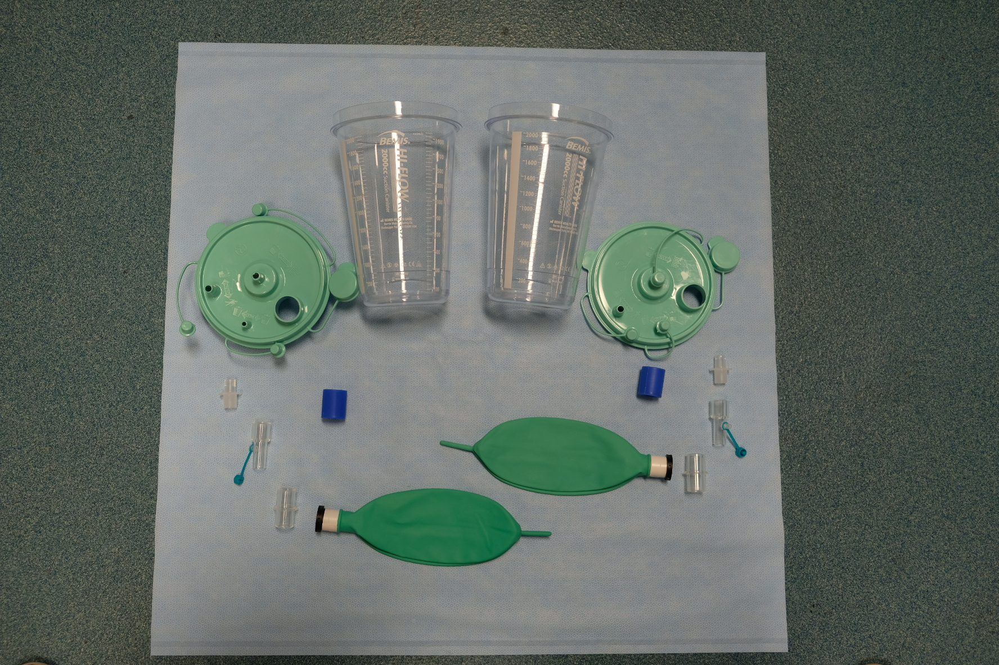

HME +   
Antimicrobial  
filter

PEEP valve   
with connector (2 options)

Manometer

Patient Tubing

Silicone   
Connector

2 L suction cannister   
and lid

ETT   
connector

Gas Sample Tee   
adapters

15 mm to 15 mm   
connector

Breathing Bag

**Cerberus System Schematic**

**Setting up the ventilator for two-patient ventilation**

|  |  |
| --- | --- |
| **Creation of the “Driving Circuits”** | |
| Step 1: | Connect 22 mm to 22 mm connector (blue) to bottom of one (1) t-piece |
|  | |
| Step 2: | Connect short blue tubing to each open end of t-piece. This becomes the common inspiratory limb split of the ventilator (Master). |
|  | |
| Step 3: | Connect the inspiratory limb t-piece (Step 2) to the common inspiratory port of the ventilator (Master) using the 22 mm to 22 mm connector previously attached (step 1) to the bottom of the t-piece. |
|  | |
| Step 4: | Connect 22 mm to 22 mm connectors to all ends of a t-piece. Use a blue 22 mm to 22 mm connector for the bottom limb of the t-piece. This becomes the common expiratory limb split of the ventilator (Master). |
| A picture containing sitting, small, suitcase, cat  Description automatically generatedA picture containing bag, bottle  Description automatically generated  → | |
| Step 5: | Connect t-tubes to each open end of the t-piece using the clear 22 mm to 22 mm connectors that were attached in step 4 |
| A picture containing indoor, sitting, small, bottle  Description automatically generated  A picture containing indoor, sitting, suitcase, luggage  Description automatically generated  ↓ Attach a two-limbed driving circuit (short blue and short clear tubings) that are y-connected to the ETT connector of the suction cannister. One driving circuit per cannister. Note: elbows are optionally placed between Y-connector and suction cannister ETT connector. | |
| Step 6 : | Connect short clear tubing to the open ends of the inter-connected t-piece setup created in step 5. |
|  | |
| Step 7: | Connect one-way valves (flow direction = towards t-pieces; indicated by red arrow) in the remaining open bottoms of the t-pieces constructed in Steps 5-6. |
|  | |
| Step 8: | Connect final expiratory limb tree to the expiratory port of the ventilator (Master) using the 22 mm to 22 mm connector (blue) placed in step 4. |
|  | |
| Step 9: | Connect one (1) common inspiratory (short blue tubing) limb and one (1) common expiratory (short clear tubing) limb to two (2) ports of a y-connector. This creates a driving circuit for one patient. |
|  | |
| Step 10: | Connect the remaining common inspiratory (short blue tubing) limb and common expiratory (short clear tubing) limbs of the driving circuit to two (2) ports of a y-connector. This creates the second driving circuit. |
|  | |
| **Construction of “Bag-in-a-bottle” \*\*** | |
| Step 11: | Use a 15 mm to 15 mm connector to connect the 1 L breathing bag to the silicone connector. |
| A picture containing laying, lying, small, green  Description automatically generated  ↓ Attach a two-limbed driving circuit (short blue and short clear tubings) that are y-connected to the ETT connector of the suction cannister. One driving circuit per cannister. Note: elbows are optionally placed between Y-connector and suction cannister ETT connector.  A picture containing laying, green, lying, small  Description automatically generated | |
| Step 12: | Cut down the silicon connector so that it is flush with the 15 mm to 15 mm connector. |
| A close up of a bottle  Description automatically generated  → | |
| Step 13: | Insert the silicone connector through the largest opening of the suction cannister lid so that bag is on the underside of the lid. Ensure that the silicone connector is flush with the exterior surface of the lid.   * In order to facilitate insertion of the silicone connector we recommend coating the exterior with an alcohol wipe before rapidly inserting the connector into the opening. |
|  | |
| Step 14: | Connect a 11.0 mm ETT connector to the tapered opening of the suction cannister lid.   * Once firm connection is established it is advisable to glue/epoxy the ETT connector to the cannister. |
| A picture containing indoor, sitting, green, small  Description automatically generated  A picture containing indoor, sitting, small, little  Description automatically generated  → | |
| Step 15: | Connect gas sample tee to the 15 mm port embedded in the silicone connector. |
|  | |
| Step 16: | Seal any additional openings on the suction cannister lid. |
| Step 17: | Attach suction cannister lid to cannister. **Seal lid to cannister using epoxy/glue.**   * Ideally, test seal to a pressure of at least 150 cm of water. |
| A picture containing sitting, table, small, glass  Description automatically generated  A picture containing indoor, person, sitting, green  Description automatically generated  → | |
| **Creation of “Individual” patient circuits** | |
| Step 18: | Connect one-way valve (direction of flow = away from cannister; indicated by blue arrow) to the open end of the gas sample tee using a 22 mm to 22 mm connector. |
| A picture containing indoor, green, sitting, small  Description automatically generated  → | |
| Step 19: | Connect the other end of one-way valve to the proximal inspiratory limb (blue tubing) of the patient tubing using a 15mm to 15 mm connector. |
| A picture containing indoor, small, sitting, blue  Description automatically generatedA picture containing indoor, sitting, bag, laying  Description automatically generated  → | |
| Step 20: | Connect a one-way valve (direction of flow = towards patient; indicated by blue arrow) to the distal end of the of the inspiratory limb (blue tubing). |
| A picture containing sitting, pair, small, laying  Description automatically generatedA picture containing sitting, white, light, water  Description automatically generated  → | |
| Step 21: | Connect the distal end of the inspiratory limb with one-way valve in place to one (1) port of a y- connector. |
|  | |
| Step 22: | Connect a one-way valve (direction of flow = away from patient; indicated by red arrow) to the distal end of the expiratory limb (white tubing) of the patient circuit using a 15 mm to 15 mm connector. |
| ↓ Attach a two-limbed driving circuit (short blue and short clear tubings) that are y-connected to the ETT connector of the suction cannister. One driving circuit per cannister. Note: elbows are optionally placed between Y-connector and suction cannister ETT connector.  A picture containing indoor, small, sink, white  Description automatically generated | |
| Step 23: | Connect the distal end of the expiratory limb (white tubing) with one-way valve in place to the other port of the y-connector using a 22 mm to 22 mm connector. |
| ↓ Attach a two-limbed driving circuit (short blue and short clear tubings) that are y-connected to the ETT connector of the suction cannister. One driving circuit per cannister. Note: elbows are optionally placed between Y-connector and suction cannister ETT connector.  A picture containing small, white, plastic, light  Description automatically generated | |
| Step 24: | place HME filter on distal port of y-connector immediately proximal to patient endotracheal tube. |
|  | |
| Step 25: | Install manometer into the gas sampling port of the HME filter   * Optionally, pressure tubing can be placed can be used to connect the manometer to the gas sampling port allowing one to extend the placement of the manometer. (as depicted) |
|  | |
| Step 26: | Connect the proximal end of the expiratory limb of patient circuit to one of the one-way valves (Step 7) found on the common expiratory tree. |
|  | |
| Step 27: | **Repeat steps 11-26 for second patient circuit.** |
| Step 28: | Attach a two-limbed driving circuit (short blue and short clear tubings) that is y-connected to the ETT connector of the suction cannister. One driving circuit per cannister.   * Elbows are optionally placed between Y-connector and suction cannister ETT connector. |
|  | |
| Step 29: | Connect fresh gas flow to the sampling port of the gas sample tee adapter.   * **Independent fresh gas flow is required for each patient circuit** * Recommended to permanently fix the fresh gas flow line to the gas sample tee in order to minimize risk of disconnection. |
|  | |

|  |  |
| --- | --- |
| **How to add independent PEEP to a patient circuit** | |
| PEEP insertion: | Insert the PEEP valve between the one-way valve located at the proximal end of the patient circuit and the common expiratory tree.   * PEEP valves with directed vented gas must be used in order to vent any escaping flow back to the common expiratory tree. * A minimum PEEP valve of 5 cm H2O required in each secondary circuit expiratory limb |
| A picture containing indoor, table, sitting, blue  Description automatically generated  ↓ Attach a two-limbed driving circuit (short blue and short clear tubings) that are y-connected to the ETT connector of the suction cannister. One driving circuit per cannister. Note: elbows are optionally placed between Y-connector and suction cannister ETT connector.  A picture containing indoor, sitting, table, sink  Description automatically generated | |

**NOTE: PEEP valve depicted cannot be substituted for more familiar mushroom valve PEEP systems seen on BMV setups unless custom casing is used.** See alternate instructions for details of custom casing

* PEEP exhaust must begivenback to the common expiratory port of the driving ventilator to satisfy the ventilator’s volume detection

**Cerberus System – Physical Circuit**

* Connect common Inspiratory Limb into inspiratory port of driving ventilator
* Connect common Expiratory Limb tree into expiratory port of driving ventilator

Connection to driving ventilator expiratory port

Connection to driving ventilator inspiratory port

